**Model Development Phase Template**

|  |  |
| --- | --- |
| Date | 29 September 2024 |
| Team ID | LTVIP2024TMID24973 |
| Project Title | Detection of Phishing Websites from URLs  Using Machine learning |
| Maximum Marks | 4 Marks |

**Initial Model Training Code, Model Validation and Evaluation Report**

The initial model training code will be showcased in the future through a screenshot. The model validation and evaluation report will include classification reports, accuracy, and confusion matrices for multiple models, presented through respective screenshots.

**Initial Model Training Code:**

**Splitting the data:**

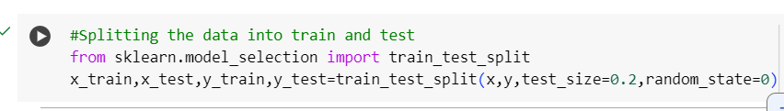

**Training the model:**

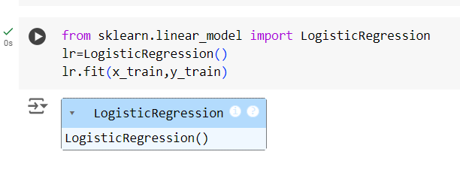

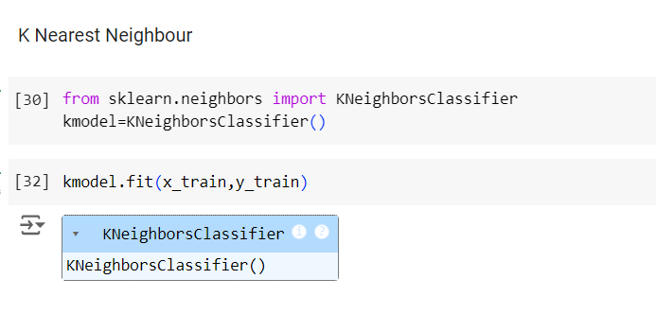

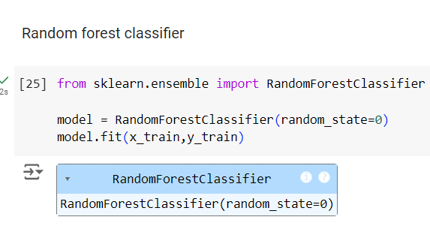

**Model Validation and Evaluation Report:**

|  |  |  |  |
| --- | --- | --- | --- |
| **Model** | **Classification Report** | **Accuracy** | **Confusion**  **Matrix** |
| Linear regression |  | 0.91 |  |
| KNN |  | 0.94 |  |
| Random Forest |  | 0.97 |  |

**Comparing of model train test accuracy:**

